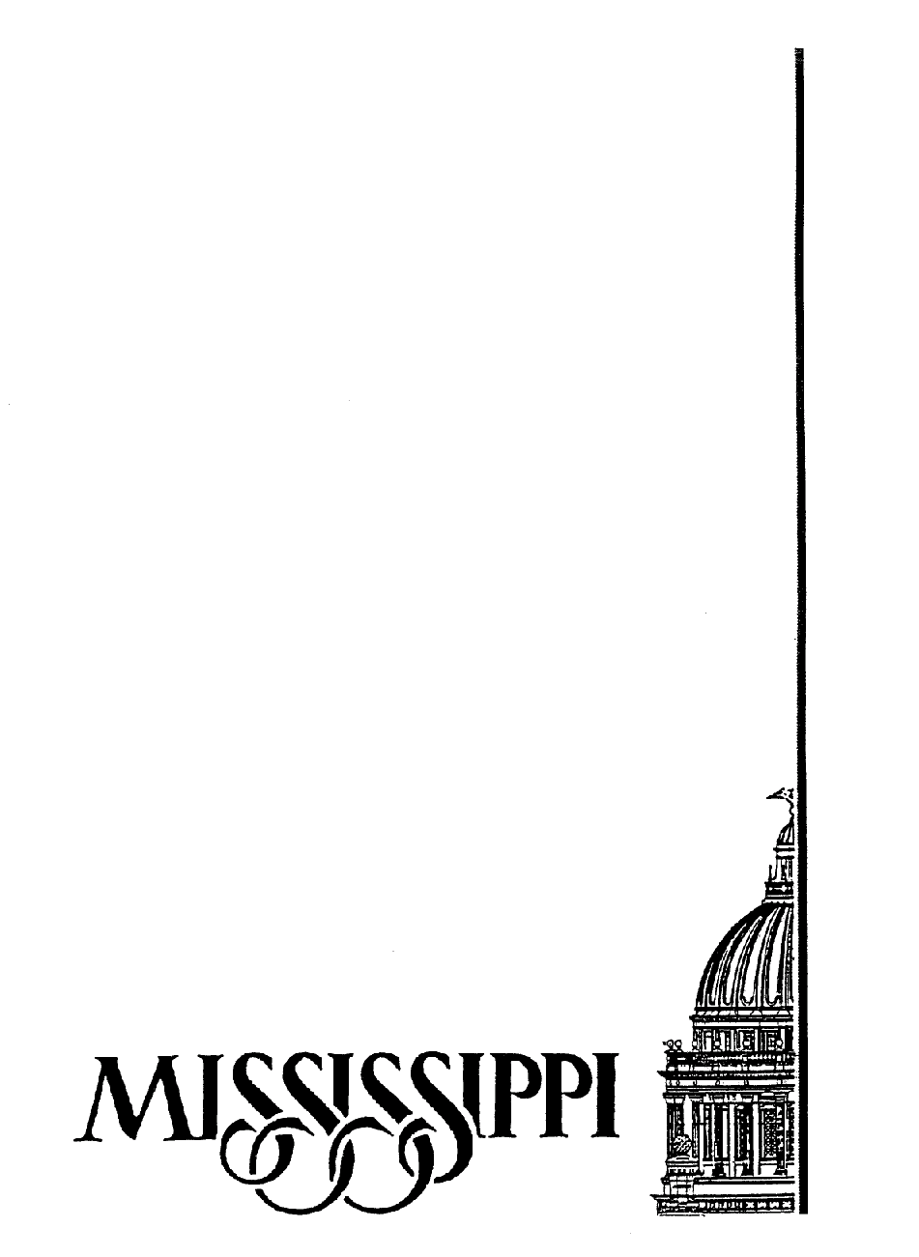

Proposal Contract ContractContract

ract
Construction

TABLE OF CONTENTS

Request for Quotes

Instructions to Bidders/Quoters ($5,000.00 - $75,000.00)

Quote Proposal (with component breakdown) ($5,000 - $75,000.00)

Contract Forms

Contract Form
Terms and Conditions (Articles 1 through 4)

Bond, if applicable (over $25,000.00) Mississippi Code of 1972, Section 31-5-51(5)

Insurance (per bid documents)
Liability Insurance - Mississippi Code of 1972, Section 31-5-51(7)
Workers Comp Insurance - Mississippi Code of 1972, Section 71-3-5

Addendum/Addenda, if applicable

Technical Specifications by Professional, if applicable

List of Drawing, if applicable

i

